Nova T6 How to Guide 7
Non Class Codes (NCC) - Part Time, PPA and all other non-classes
NCC Screen
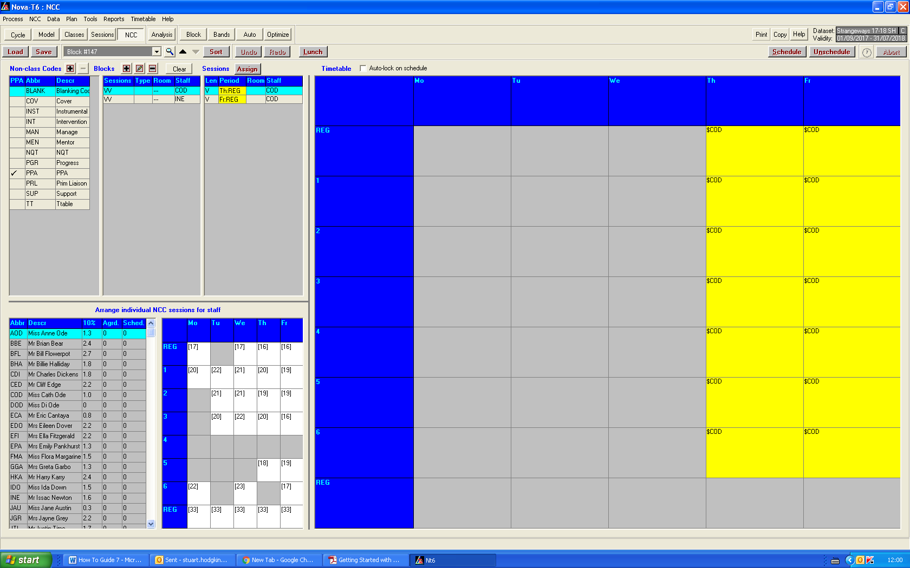
Shows timetable view of selected staff NCC.
Show COD has blank Thurs/Fri

Details of selected staff with NCC code
COD in this case

Details of selected NCC. Blank in this case

Defined NCC

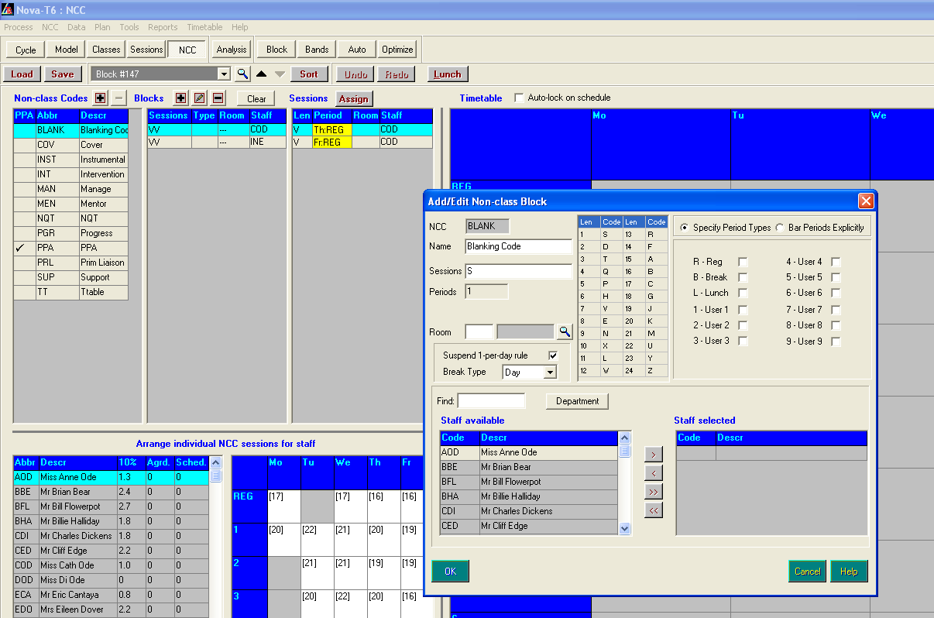
Adding Part Time Staff

Select Add Blocks

Find TBA
Highlight TBA
Select by using arrow

Enter session e (as this is a block of 8 lessons = All day)
Select Bar Periods Explicitly - This is because Reg and HW are different period types
OK

Select Assign

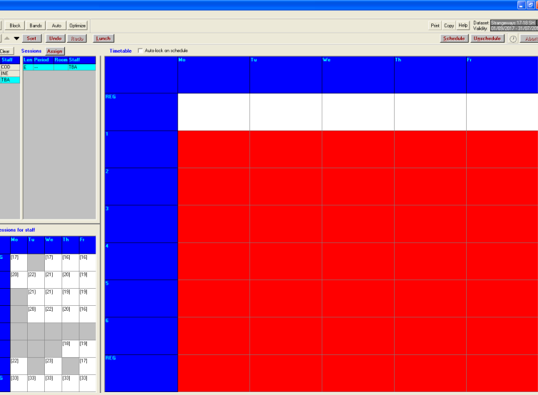

Left Click TBA and White squares will show where blanking block can be placed - all days are possible.
But drag and drop in Tuesday

